**INITIAL USER RESEARCH PROTOCOL FOR FIREFLYX**

**Overview of the Study**

The goal of the study is to design and develop a mobile application that children can use to play with and learn music. It hopes to answer the following questions:

* What playful behaviors do children exhibit when composing music?
* What features can be designed to a mobile application tool that enable playful interactions when composing music?
* What behaviors do children exhibit when using a mobile application tool to compose music?

We are currently in our phase 1 of our research framework wherein we need to do some initial user research to proceed with the design of our mobile application.

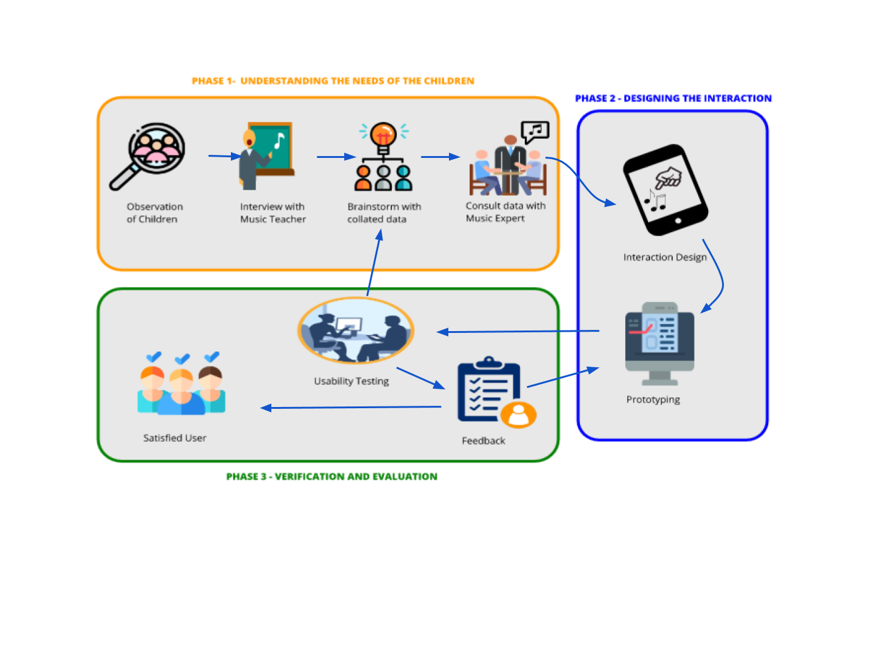

**Pre-test**

* Have a teacher distribute the consent forms to the children and have them tell the children to pass the reply slips to their parents. They are also encouraged to ask questions and make clarifications before, during, and after the experiment.
* Once all reply slips are confirmed, coordinate with school in order to set up a date and venue for the experiment.
* Buy snacks for the children.
* Orient children about the recording equipment that will be used.
* Prepare children information sheet, where the contact details, nickname, and age of the children will be recorded.

**Testing**

* Explain to the participants exactly what will happen and what they are required to do.
* The children will be given specific tasks wherein they are encouraged to do their best to complete.
* While the experiment is being conducted, cameras and microphones will be recording all events so that the entire group may observe and confirm all findings from the experiment.

**Post-test**

* The children will be interviewed and asked questions about their performance in completing the said tasks.
* The children will also be given tokens of appreciation for participating such as candies or snacks.